5.3. Generate the coefficients of an FIR High-Pass filter using Hanning windowing techniques

CODING:
clc; clear; close all;
%% --- Input Parameters ---
fp = 1000; % High-pass cutoff frequency (Hz)
fs = 8000; % Sampling frequency (Hz)
N = 50; % Filter order
wc = fp/(fs/2); % Normalized cutoff (0–1)
%% --- FIR High Pass using Hanning Window ---
b_hann = fir1(N, wc, 'high', hanning(N+1)); disp('--- High-Pass Coefficients (Hanning Window) ---'); disp(b_hann');
%% --- Frequency Response Plots ---
figure;
freqz(b_hann,1);
title('High-pass FIR using Hanning Window');

OUTPUT:
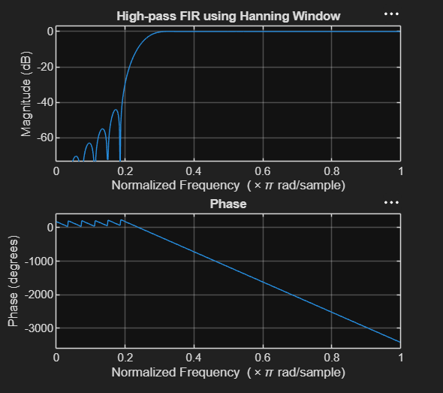

RESULT :
-- High-Pass Coefficients (Hanning Window) ---
-0.0000
0
0.0003
0.0008
0.0009
0
-0.0020
-0.0038
-0.0035
0
0.0057
0.0100
0.0087
0
-0.0127
-0.0216
-0.0183
0
0.0267
0.0464
0.0410
0
-0.0726
-0.1568
-0.2243
0.7500
-0.2243
-0.1568
-0.0726
0
0.0410
0.0464
0.0267
0
-0.0183
-0.0216
-0.0127
0
0.0087
0.0100
0.0057
0
-0.0035
-0.0038
-0.0020
0
0.0009
0.0008
0.0003
0
-0.0000

>>

